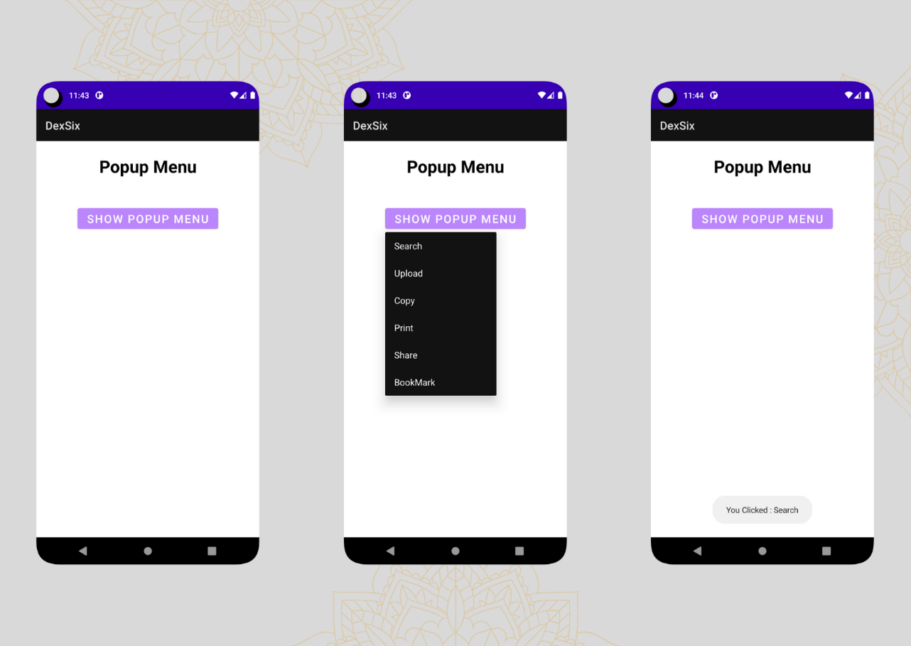

package alpha.dex.dexsix

import androidx.appcompat.app.AppCompatActivity

import android.os.Bundle

import android.widget.Button

import android.widget.PopupMenu

import android.widget.Toast

class Popup : AppCompatActivity() {

override fun onCreate(savedInstanceState: Bundle?) {

super.onCreate(savedInstanceState)

setContentView(R.layout.activity_popup)

val btn = findViewById<Button>(R.id.btnShow)

btn.setOnClickListener {

val popup = PopupMenu(this, btn)

popup.menuInflater.inflate(R.menu.popupmenu, popup.menu)

popup.setOnMenuItemClickListener {

Toast.makeText(

applicationContext,

"You Clicked : " + it.title, Toast.LENGTH_LONG

)

.show()

true

}

popup.show()

}

}

}